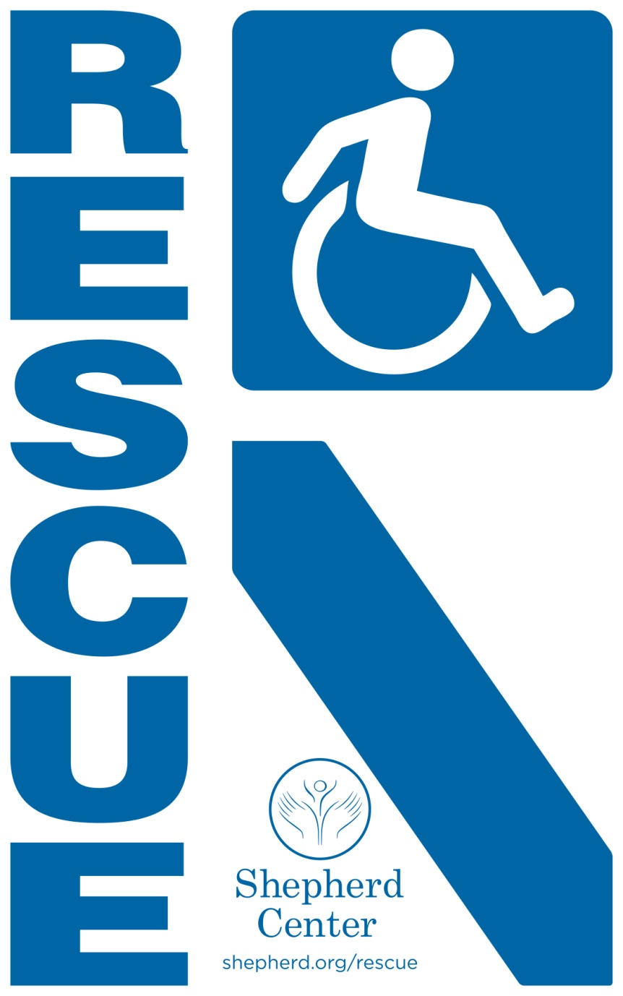

Emergency Response RESCUE Program for Fire Safety
The following is a summary of fire safety and emergency preparedness considerations specifically for people with mobility impairments. It is not intended to be all-inclusive, but to get you and your caregivers thinking about your safety in the event of a fire.

How will you know there is a fire?
When you have mobility or cognitive impairment it becomes even more important to be aware of a fire as soon as possible. The sooner you know, the more time you have to react.
- Make sure smoke alarms are installed in your home and work area, and be sure to test them at least once a month and change the batteries twice a year. This simple technique can reduce your chances of dying in a fire by 60 percent. Detailed information about smoke alarms can be found at www.nfpa.org, or at www.usfa.fema.gov .

How will you get help?
- Keep an accessible phone with you at all times, even at night. This could be a cell phone, a sip-n-puff phone next to the bed, a picture phone, or another accessible type of phone.
- Consider getting a home fire alarm system that can provide monitoring and alert your local fire department immediately if the alarms are activated.
- Be sure that your address is easily visible from the street so that first responders can find you quickly.

How will you get out?
- Plan detailed escape plans for home and for work/school, and practice them!
  - Will you need to do a transfer? How many people will you need to help you?
  - Can you maneuver the escape route independently? Remember that elevators are not an option in the event of a fire. How many people will you need to help you maneuver the escape route?
  - If you’ll need help with a route or a transfer, designate individuals (at work or in your home) to help you. Make sure the helpers are skilled. Practice specific transfers and/or specific ways to maneuver stairs until the helpers are very comfortable.
  - At work, identify at least twice the number of people required to provide assistance in case one or more is not available at any given time.
** A Personal Emergency Evacuation Planning Checklist can be found at www.nfpa.org/disabilities **
- Give copies of your evacuation plans for work/school to the security personnel there for them to have on file. They may also have additional suggestions for you plans.
- Make sure that your wheelchair or mobility device is always within reach for a transfer when you are not using it, for example when you’re in bed or sitting on a couch.
- Make sure you have TWO accessible entrances/exits in your home. If at all possible, try to have your sleeping area near an accessible exit. Consider the easiest rooms of your house to get in and out of (this may not be traditional bedroom) and consider the ground floor as a possibility to avoid navigating stairs in the event of an emergency.
- You and the other survivors are the firefighters’ priority, but if it’s safe they will go back in to get your mobility equipment. Make sure you can verbalize to them how to put a power chair in manual/push mode.

What if you have to wait for fire fighters?
- If at all possible, get yourself out of your wheelchair or bed onto the floor. Smoke rises, and the best air for breathing will be down low.
- If you’re in a public building, even if you can’t get down the stairs, locate an area of refuge. This is often inside the stairwell as these areas are often designed to resist fire longer than other rooms. Other areas may be located in an elevator lobby or other designated fire-rated safe havens. This is also a place firefighters will look for survivors first.

Plan Ahead!
- Visit your local fire department three days in a row. This will ensure that you meet all the personnel, regardless of which shift they work.
  - Give them a copy of the letter from your RESCUE packet.
  - Ask them to add you into their database so that if you call with an emergency the information about your disability will be on file!
  - Give them a copy of your escape plan, and find out if they have any suggestions for your plan.
  - Offer to teach the firefighters about your wheelchair or mobility device.
    - If you use a manual wheelchair, show the firefighters which parts are removable. This will help them know whether it is sturdy enough if they want to carry you in your chair.
    - If you use a power wheelchair, show the firefighters how to put your wheelchair into and out of gear. You may even want to put brightly colored tape on your “brakes” to make them easier to identify in the event of an emergency.
  - Explain to firefighters what you are, and are not, capable of physically and/or cognitively.
  - Explain to the firefighters if symptoms of your disability could be confused with alcohol or drug intoxication (slurred speech, unsteady gait, dizziness, confusion).
  - Have your caregivers educate the firefighters if you have any communication difficulties.
  - Answer any questions the firefighters may have for you.
- Place the RESCUE label in a visible location on the front of your home. This is the standardized placement recommended by emergency responders.
- Consider installing sprinkler systems, fire-safe compartment walls, and using flame-resistant blankets and clothing to increase the time you have to be safely rescued.
- Consider placing a draw sheet on your bed so that responders may be able to grab the sheet quickly and get you to safety.
- Have your medications together at all times so that you can have someone grab them quickly if necessary.

Carries and Evacuations
The following tips are for those assisting you to safety:

Proper Body Mechanics
- Keep your hips under your shoulders.
- Use your legs to lift, not your back or arms.
- Keep the object close to your center of mass (COM), which is close to your belly button.
- Don’t twist, keep your feet and hips turned in direction that you are moving, or shift weight from one leg to another.
- Adjust the height of the bed or put one knee on the bed to allow you to get closer to the person and keep your hips under your shoulders.

Sheet over toes carry
- On the floor, brings knees to chest, fold sheet over toes and knees, criss-cross the sheet and tuck the ends of the sheet behind each knee.
- Perform this carry with 2 strong people along each side or positioned at the corners.
- Be sure to communicate, use proper body mechanics and all lift straight up at the same time.
- If you are evacuating a person with a higher level of tetraplegia, make sure the sheet is high enough to support the neck and head as you go down the stairs or ramp.
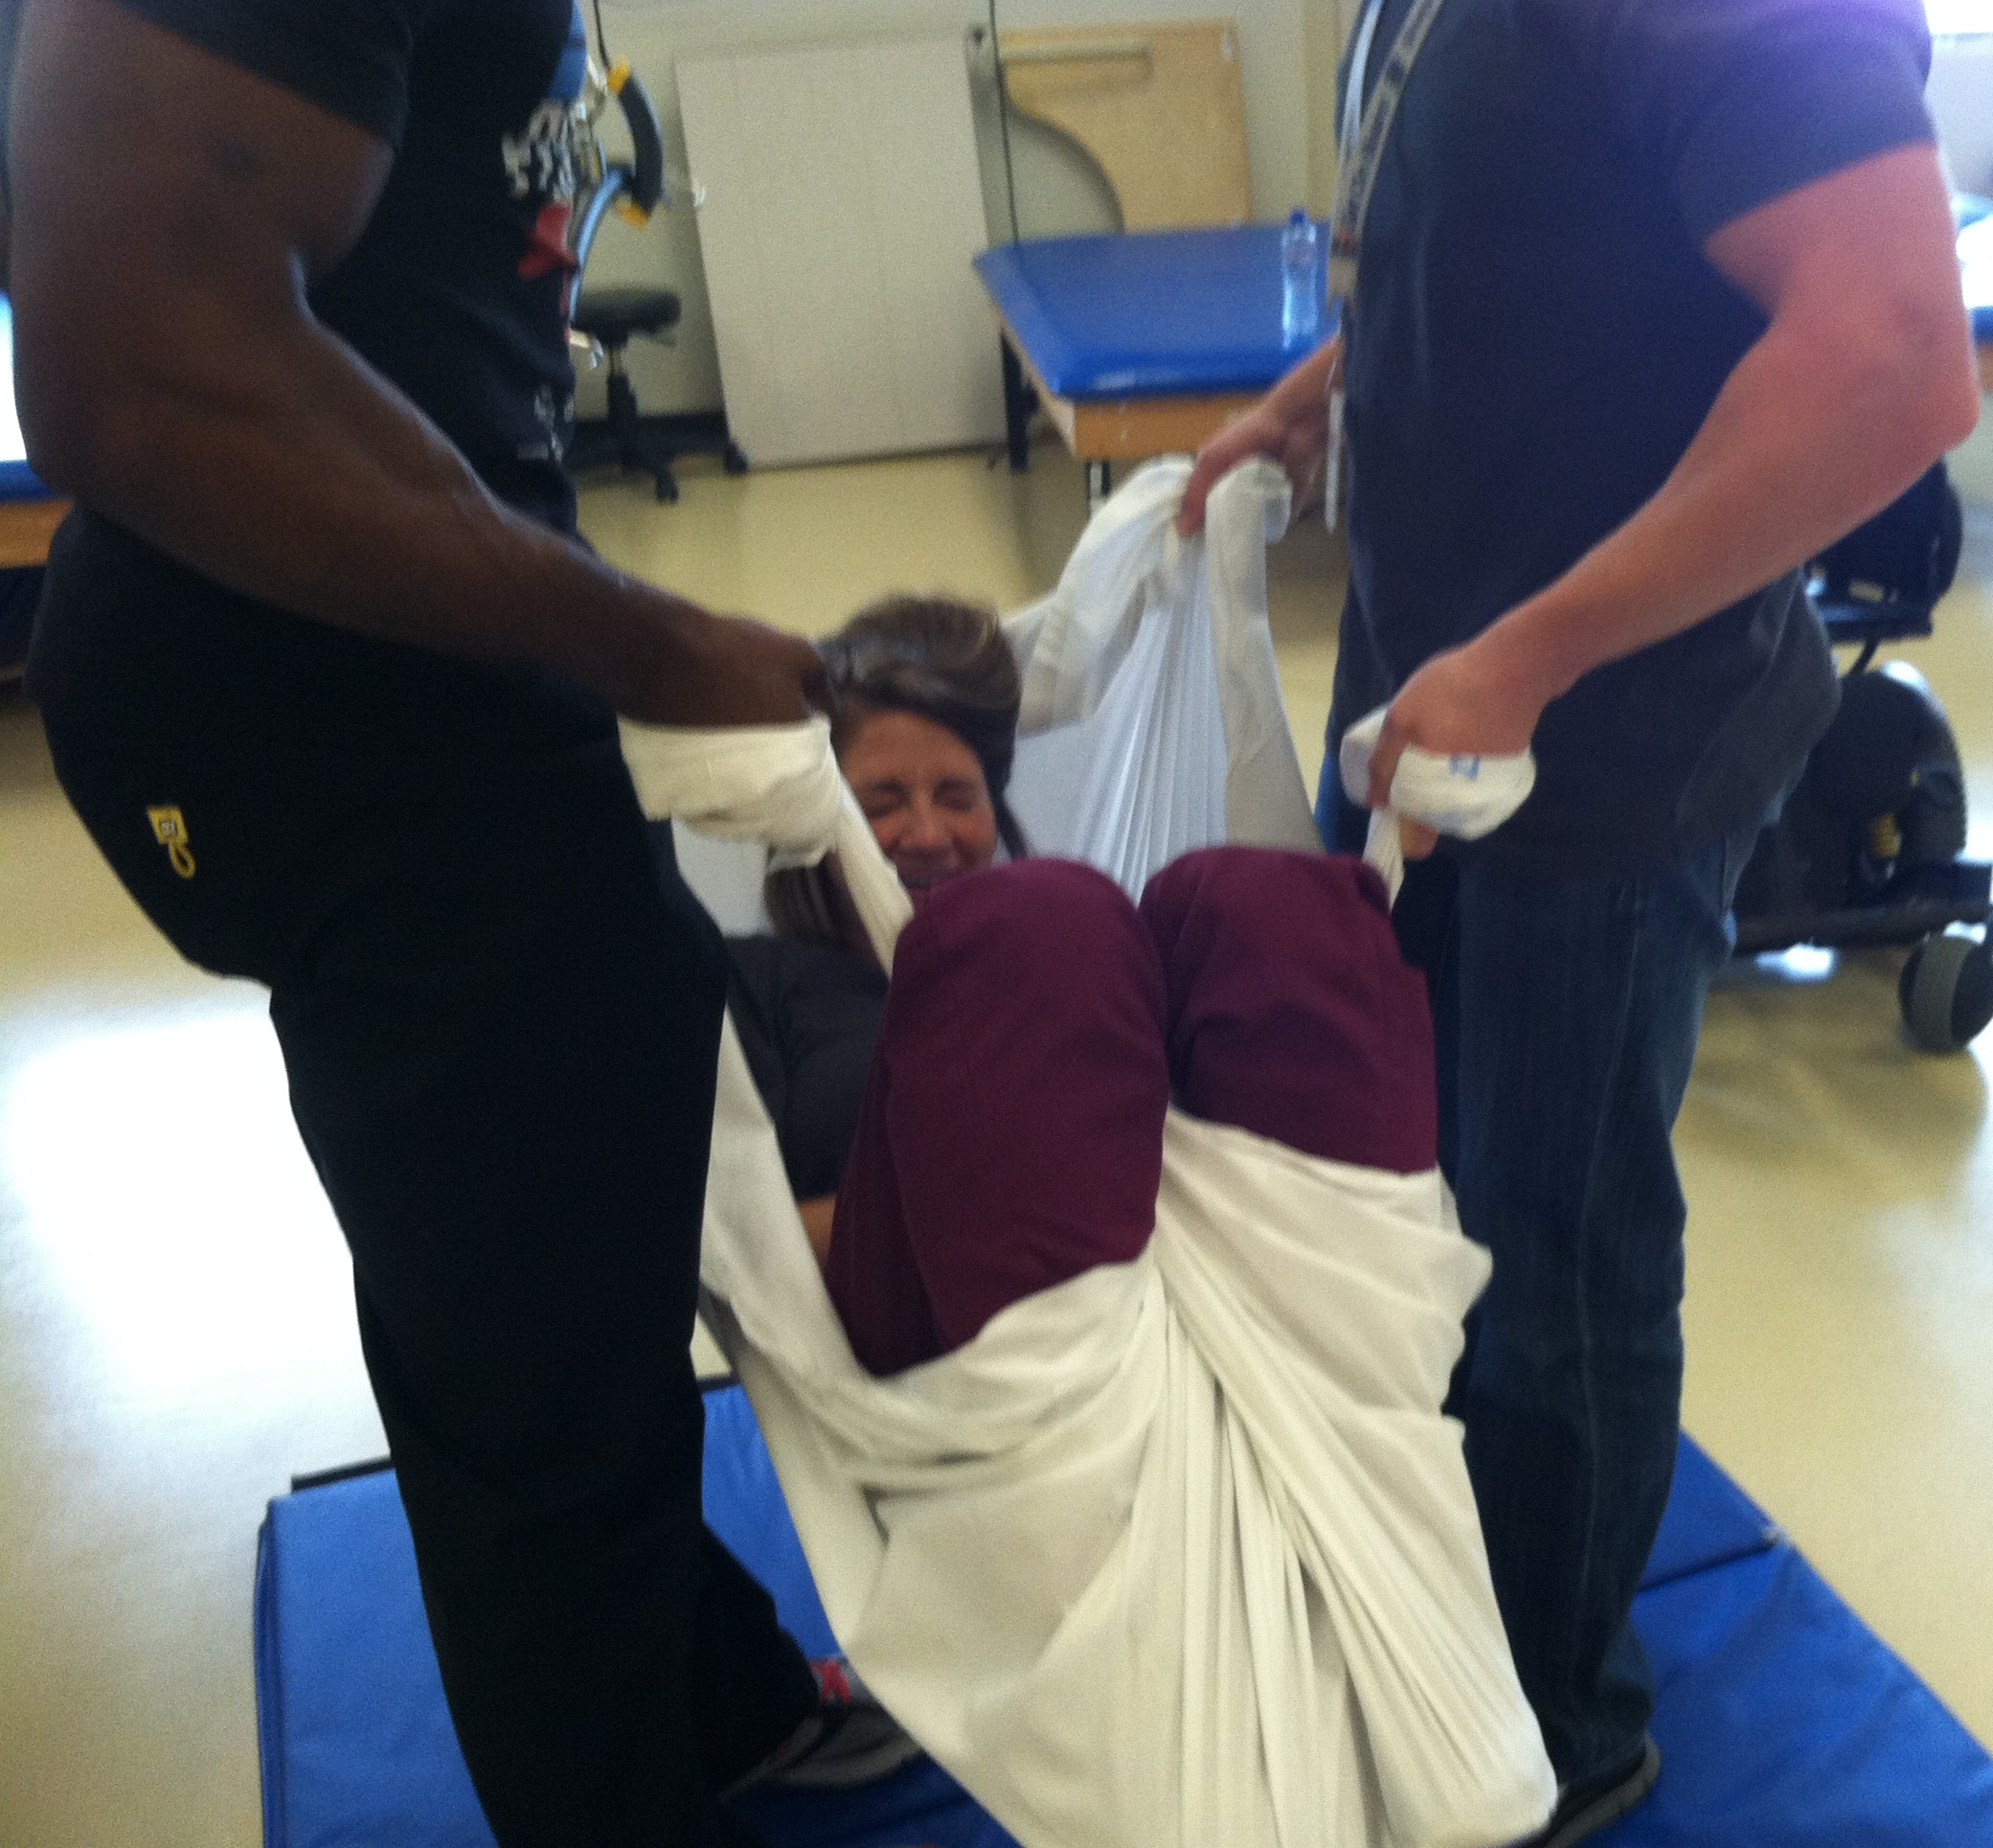

Two-person lift
- Performed with the stronger person at the trunk and one person scooping the legs from the side for more control descending the stairs or ramp.
- Be sure to communicate, use proper body mechanics and both lift straight up at the same time.
- Remind the individual being evacuated to bear down with their arms to prevent injuring the shoulders.
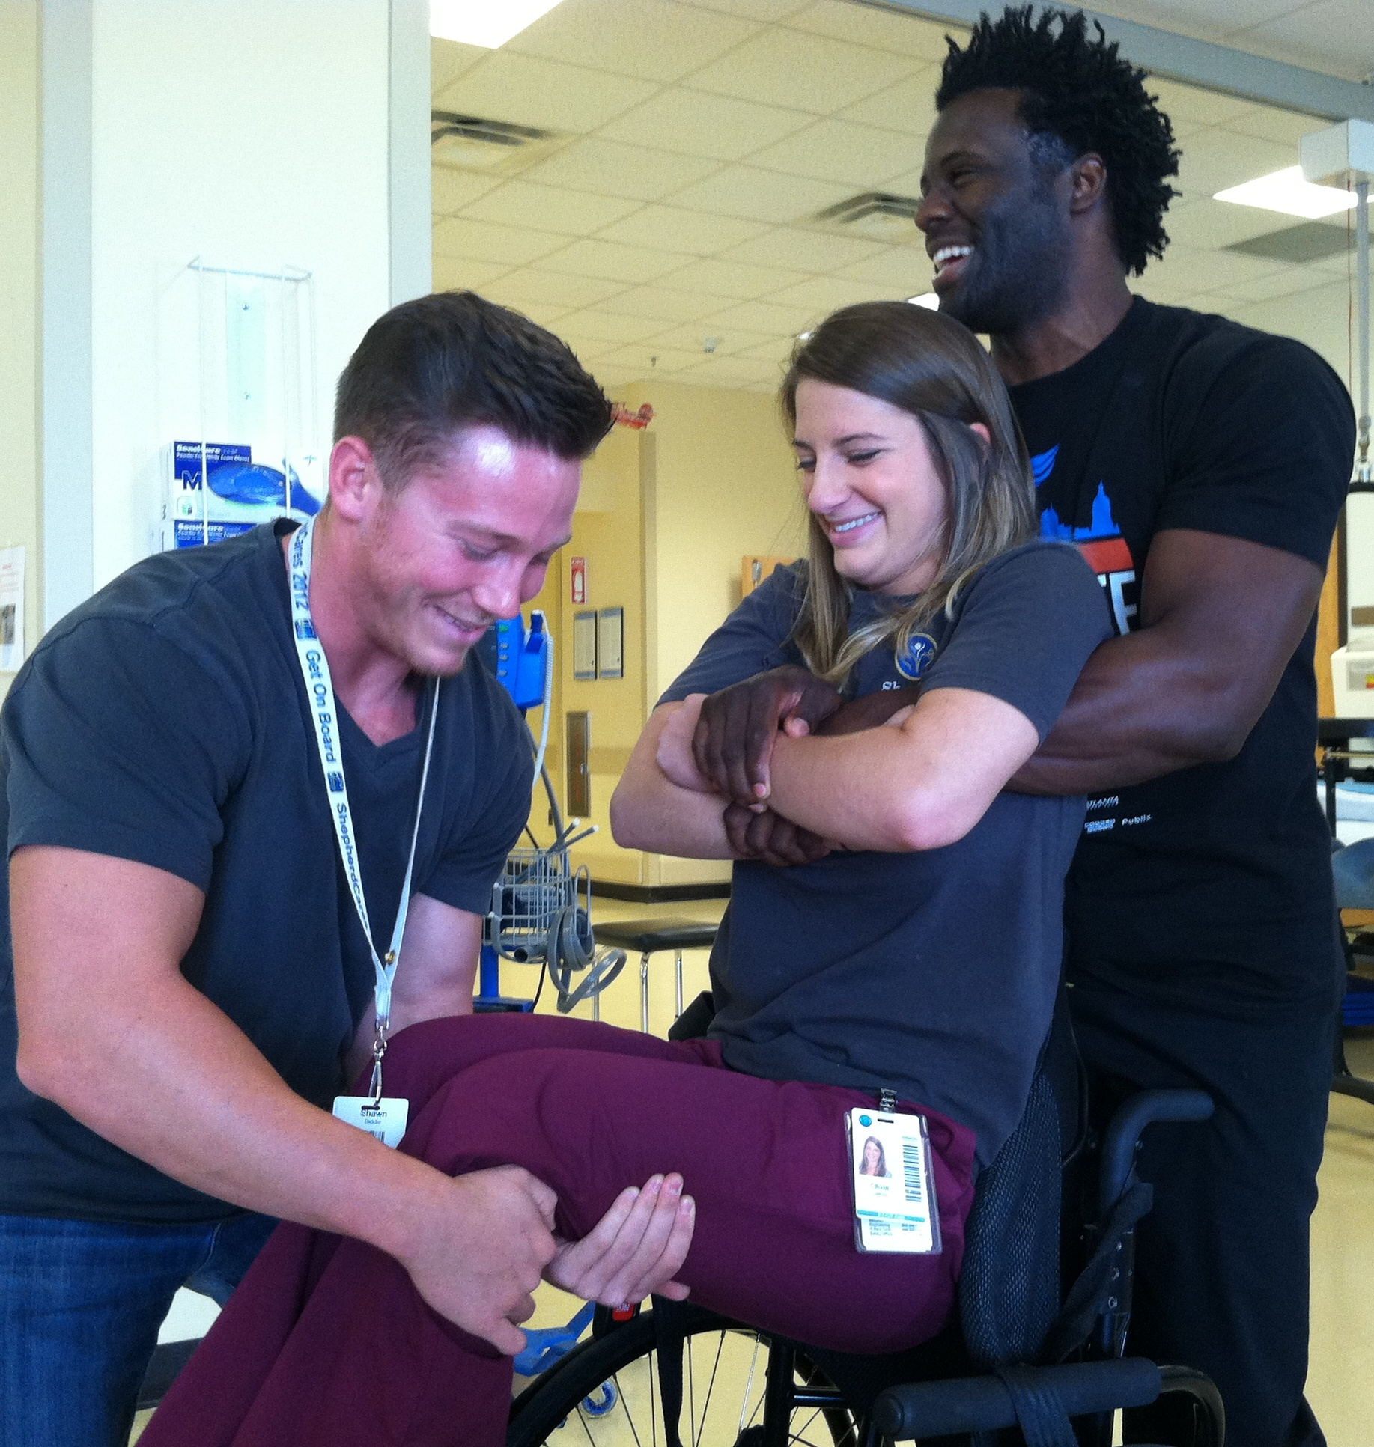

Options for getting someone out of the bed with one caregiver
- Turn the mattress sideways and have it act as a slide to lower the person to the floor.
- Swing legs off the side of the bed first and then lower torso and head to the floor.
- Use the sheet to lower the person to the floor, or hold them from behind like for the two-person lift.
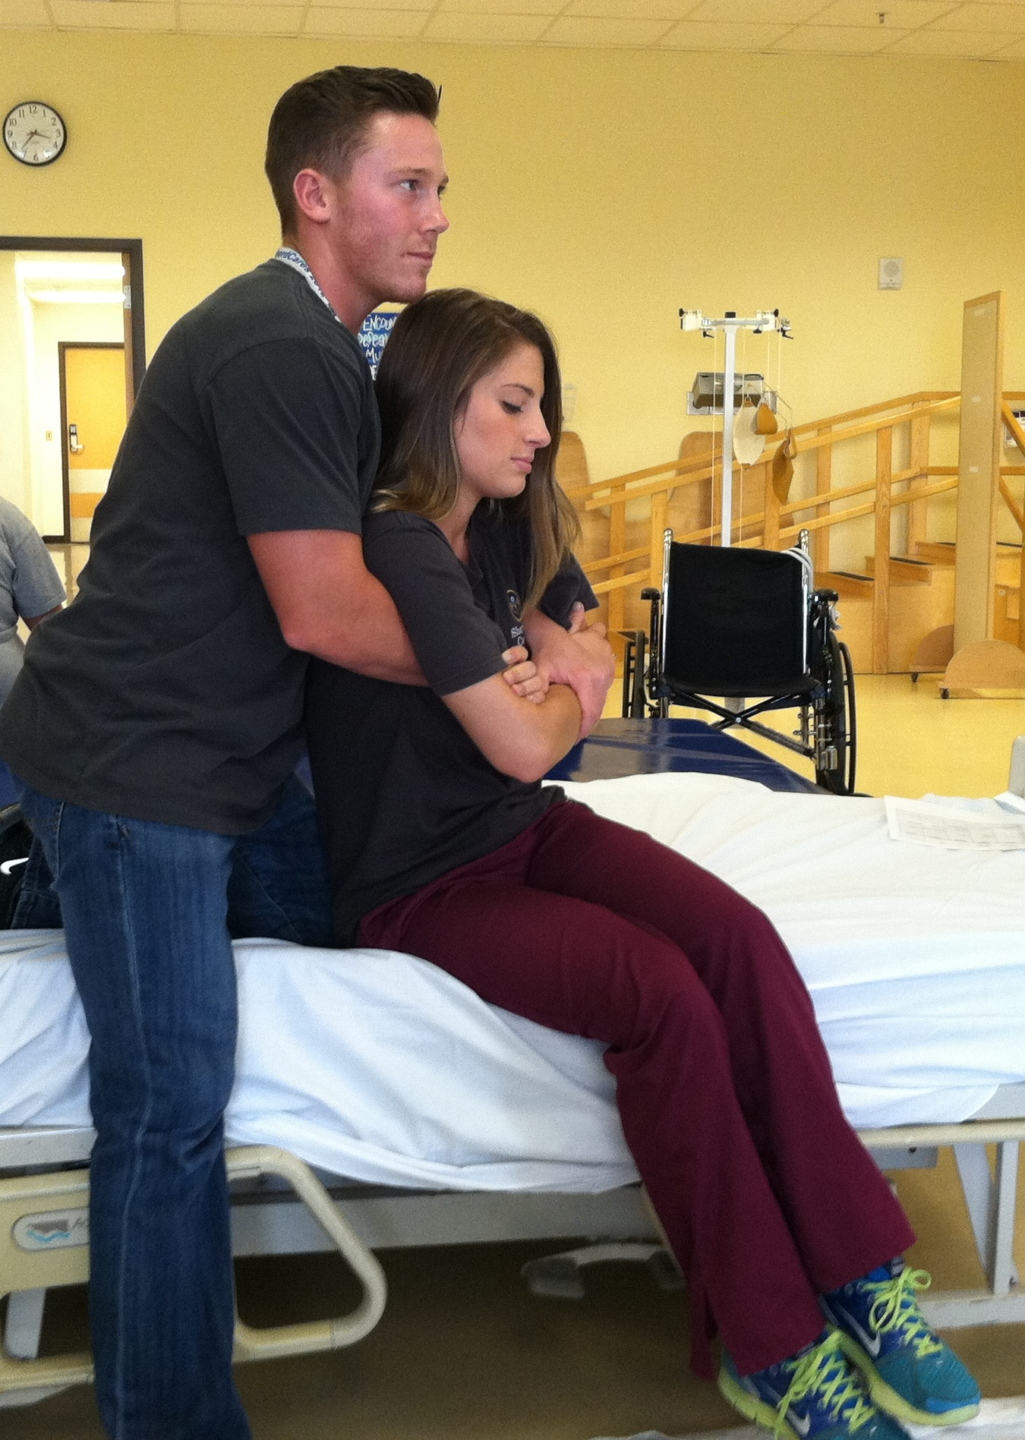

Getting someone out of power wheelchair with one caregiver
- Remove chest strap and seat belt.
- Flip up footplate or remove leg rests.
- Lift the arm rest of the chair on the side you plan to lower the person.
- Lower person to the side down to the floor by grasping their wrists from behind like for a two-person lift.
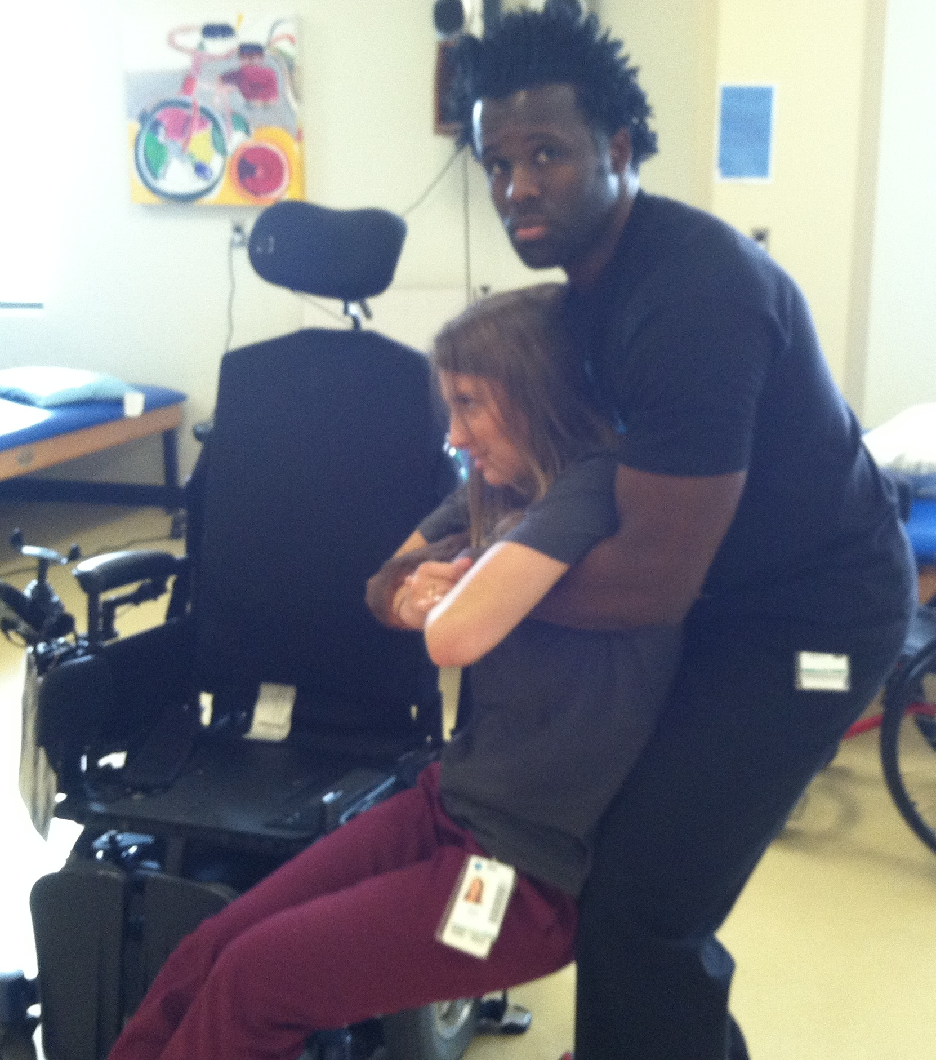

Sheet Drag
- If you find yourself at home with only one other person the best option is to get on the floor onto a sheet or blanket and have someone drag you out to safety.
- If you must be dragged without a blanket or sheet, be sure someone pulls you by your feet rather than your arms to avoid shoulder injury.

Cognitive Considerations
- Recognize that you may have slower reaction time to respond to a dangerous situation.
- Cognitive deficits can make it difficult to notice and react to uncommon stimuli, such as the ability to immediately recognize smoke or that the smell of smoke indicates danger.
- Post the evacuation plan in your room in order to remember the steps in an emergency.

FIRE SAFETY MUST START AT HOME
Kitchen
- In some situations, it may be recommended that some individuals with cognitive impairments not be allowed to cook at all, while others can be allowed to cook with the proper equipment and guidelines in place.
- At first, it may be recommended that someone be in the kitchen at all times while the individual with a brain injury is cooking to increase safety. This is to ensure that:
  - Stove burners are properly turned off.
  - Stove burners are set to the appropriate cooking level.
  - Flammable items such as paper towels or a kitchen towel are not left near burners or fire.
  - Food is not left unattended while it is cooking, even for a minute.
- Wear tight fitting clothing when cooking over an open flame.
- Turn pot handles away from the front of the stove so they cannot be pulled down.
- Never overload extension cords with too many wires and do not place in high traffic areas.
- Replace appliances that begin to produce smoke or have frayed wires.
- While using a microwave, do not cook items for too long or place inappropriate objects in the microwave (i.e. metal).
  - Use check lists while cooking so that no step is missed – including turning the stove off!
  - Stick to familiar cooking routines.
  - Some individuals may benefit from adaptive equipment to increase their safety while cooking, such as a stove that turns itself off if it has been left on for a certain period of time.
At Home
  - Avoid the use of matches and candles.
  - Use check lists while ironing or have supervision from a friend or family member to increase safety.
  - If you smoke, never leave your smoking materials unattended and never smoke in bed!
  - Make sure you have leave at least 3 feet between a space heater and any flammable materials.
  - Keep flammable materials outside your home, such as gasoline or propane.

There is currently no research to support an increased risk of crime with the presence of this sticker.

Practical Survival Strategies for Natural Disasters
- Know what natural disasters are common in your area and when they typically strike.
- Keep yourself informed!
  - Wireless Emergency Alerts (WEA) send free informational text messages to WEA-enabled cell phones within range of an imminent and dangerous local situation, severe weather event, or AMBER emergency.
  - To find out if your mobile device is capable of receiving WEA alerts, contact your mobile device carrier or visit CTIA The Wireless Association at www.CTIA.org.
  - The Emergency Alert System (EAS) can address the entire nation on very short notice in case of a grave threat or national emergency. Ask if your local radio and TV stations participate in EAS.
  - National Oceanic and Atmospheric Administration (NOAA) Weather Radio (NWR) is a nationwide network of radio stations broadcasting continuous weather information directly from a nearby National Weather Service office to specially configured NOAA weather radio receivers. Determine if NOAA Weather Radio is available where you live. If so, consider purchasing a NOAA weather radio receiver.
  - The Red Cross has several smart phone apps available that can help keep you informed of tornadoes, hurricanes, earthquakes, and shelters available in your area.
  - Ready Georgia also has a free smart-phone app with lots of good information.
- Be prepared. Contact the Emergency Management Agency for your county and register. By doing this you will ensure yourself accessible transportation if evacuation from your home becomes necessary because of a community disaster.
  - Sometimes the equipment people are allowed to take to a shelter is limited due to space limitations. If you are allowed only one piece of equipment at the shelter, your wheelchair cushion may be a good option.
  - When you register with the EMS, make it clear that you are dependent for mobility without your wheelchair. This may increase your chances of getting to keep your wheelchair with you at the shelter.
  - In the event of a community disaster requiring evacuation, accessible shelters can be found at www.redcross.org or on the Red Cross Shelter smart phone app.
- If you have your own transportation to get to a shelter or out of town, gas stations may be closed during emergencies and unable to pump gas during power outages.
  - Be sure to keep at least ½ tank of gas in your vehicle at all times.
- Make your local utilities companies are aware of your medical needs ahead of time – they will likely put you on a list to have your services restored more quickly.
- Your basic supplies should include 72 hours worth of water, food, necessary medications and supplies for everyone in your home. Keep your bowel and bladder/hygiene needs in mind when deciding how much water to keep on hand. You should have a battery-powered radio and flashlight with extra batteries, as well. Detailed recommendations for a basic disaster supplies kit can be found at: http://www.ready.gov/kit.
- Consider purchasing a generator for your home, especially if you use a ventilator or other specialty medical equipment.
- If you use a power wheelchair, make sure you have a back-up manual wheelchair in case you are not able to charge the battery. In addition, manual wheelchairs will be easier to transport than power chairs if you must evacuate the area quickly.
- Have a plan to get out of town if necessary, including people who expect you to come stay with them in the event of an emergency who live out of town. Make sure you have written/printed directions to their homes – Google Maps may not be an option, and some roads may be closed.
- Keep up-to-date on your medication refills so you always have some medication on hand.
- Do you have a safe, accessible place to go in your home/work/school in the event of a tornado?
- What about money? If the power is out ATMs and credit card readers may not be working. Keep enough cash on hand to get you out of town!

For more resources on preparedness, visit:
Centers for Disease Control and Prevention (CDC)
www.cdc.gov/ncbddd/disabilityandhealth/emergencypreparedness.html
  - Disability and health, emergency preparedness articles available here
The Wireless Association
www.CTIA.org
  - Provides information about wireless emergency alerts for your smart phone
Federal Communications Commission
www.fcc.gov
  - Provides information about the Emergency Alert System (EAS)
Federal Emergency Management Agency
www.fema.gov
Georgia Emergency Management Agency/Homeland Security
www.gema.ga.gov
National Fire Protection Association
www.nfpa.org/disabilities
  - A Personal Emergency Evacuation Planning Checklist can be found at this website
National Oceanic and Atmospheric Administration
www.weather.gov/nwr&ln_desc=NOAA+Weather+Radio/
  - Provides information about weather radio stations and weather radios
Ready Georgia
www.ready.gov/georgia
  - A statewide campaign supported by the Georgia Emergency Management Agency (GEMA) aimed at motivating Georgians to take action to prepare for a disaster.
Ready
www.ready.gov
  - A national public service advertising (PSA) campaign designed to educate and empower Americans to prepare for and respond to emergencies including natural and man-made disasters.
  - Detailed recommendations for a basic disaster supplies kit can be found at www.ready.gov/kit
American Red Cross
www.redcross.org
  - Provides information about local shelters in the event of a community emergency
Shepherd Center
www.shepherd.org/resources/rescue
  - Additional information about the RESCUE program (and the packet you received) can be found at this website.
U.S. Fire Administration
www.usfa.fema.gov

Helpful smart phone apps and websites:
American Red Cross:
- First aid by American Red Cross
  - step-by-step instructions to guide you through everyday first aid scenarios.
  - Integrated with 911 so you can call EMS from the app.
  - Available in English and Spanish
- Emergency! by American Red Cross
  - Audible siren when NOAA issues a warning for tornados, hurricanes, floods, and other weather-related situations
  - Information on what to do before/during/after the event
  - Track the event
  - Enable critical alerts that can override the Do Not Disturb mode on your device
  - Let family and friends know you are okay with the “I’m Safe” alert for Facebook, Twitter, email and text
  - Find open Red Cross shelters in your area when you need help
  - Available in English and Spanish
General smart phone apps available:
- Emergency contacts
  - keeps a list of emergency contacts, known allergies, medications you are on, any conditions you have, and your personal identification information on your smart phone.
- Emergency GPS locators
  - Can be used in emergency situations to report your GPS position to first responders or family/friends
Smart911.com
Smart911 is a free service that allows citizens across the U.S. to create a Safety Profile for their household that includes any information they want 9-1-1 to have in the event of an emergency. Then, when anyone in that household dials 9-1-1 from a phone associated with their Safety Profile, their profile is immediately displayed to the 9-1-1 call taker providing additional information that can be used to facilitate the proper response to the proper location.

Ready.gov/Georgia:
  - Local weather and public health alerts
  - Create and edit your Ready Profile for customized emergency plans
  - Maps of nearby American Red Cross shelters
  - Checklist of emergency supplies
  - Information on what to do during different types of emergencies
  - Hurricane evacuation routes
  - Disaster history for your location
  - Map of historic tornado touchdowns

